**HARDWARE COMPONENTS;**

* Hardware Specifications
* Arduino Uno
* Wifi Module
* Temperature Humidity Sensor
* Ultrasonic Sensor
* Water Flow Sensor
* Water Level Sensor
* LCD Display
* Resistors
* Capacitors
* Transistors
* Cables and Connectors
* Diodes
* PCB and Breadboards
* LED
* Transformer/Adapter
* Push Buttons
* Switch
* IC
* IC Sockets

**SOFTWARE COMPONENTS ;**

* Wokwi
* Arduino code
* ESP32 DevKit
* Visual code studio

**DEVLOPMENT OF FLOOD MONITERING;**

• Sends alert in the event of rising water levels and classification such as warning ,critical and high critical.

• Helps to product against possible water damage.

• Reduce or prevent the dertermental effects of flood water.

Raspberry Pi3 it is the central controller for data collection processing and communication

And water level sensor that is ultra sonic sensor pressure sensor or float switches can be used to measure the water level and also it measure the rainfall intensity that is Called As rainfall sensor

Then communication module its depending on the connectivity of options you might need a wifi module

Power suppky is an ensure a stable power supply for your raspberry pi and sensor which needs may includes a battery backup system

Then we can choose the iot platfrom tp manage and visualize our date that will be shown bellow

1.AWS IOT CORE

2. GOOGLE CLOUD IOT CORE

3. MICROSOFT AZURE IOT HUB

4.BLYNK

5. IBM WASTON IOT

Connect the water level and rani fall sensor to the GP10 pins of the raspberry pi.

Write the sensor code and devlop the code to read the date from the sensor using GP10 ins and interface libraries for our programming language

Analyeze the process the sensor date on the raspberry pi . this may include setting threshold values for flood monitering

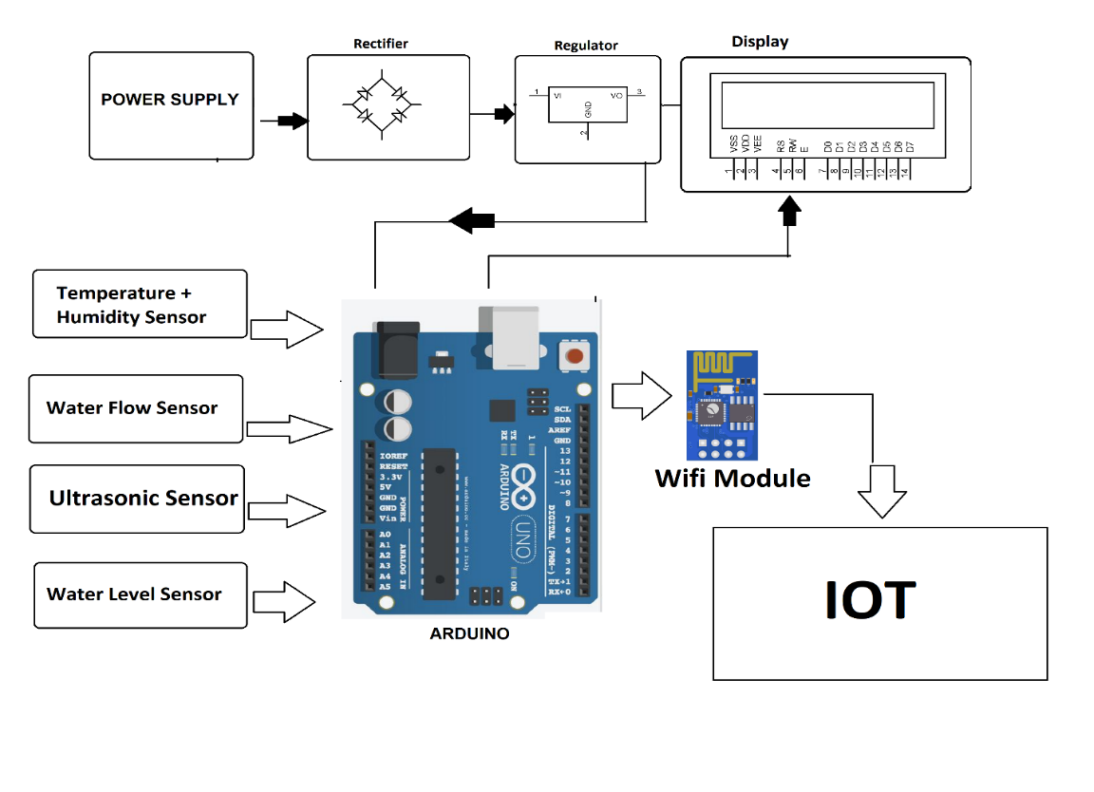

Depending on our communication module send the processed data and implement the security measure like an authentication.

Data base integration is used to sore the collected data to the memory derive based on water level and rainfall level

Regular monitering that Is d3fined as an continuously moniter the system performance ,sensor health,and data integrity .

Python script

import RPi.GPIO as GPIO

import time

import requests

# GPIO pin connected to the water level sensor

WATER_LEVEL_PIN = 18

# Threshold for water level (adjust based on your sensor and requirements)

WATER_LEVEL_THRESHOLD = 100 # Example threshold in millimeters

# API endpoint for sending alerts

ALERT_API_ENDPOINT = "https://example.com/alert"

# Initialize GPIO settings

GPIO.setmode(GPIO.BCM)

GPIO.setup(WATER_LEVEL_PIN, GPIO.IN)

def send_alert():

# This function sends an alert using API endpoint

data = {

"message": "Flood Alert! Water level has exceeded the threshold."

}

try:

response = requests.post(ALERT_API_ENDPOINT, json=data)

if response.status_code == 200:

print("Alert sent successfully!")

else:

print("Failed to send alert!")

except Exception as e:

print("Error occurred while sending alert:", str(e))

try:

while True:

# Read water level sensor data

water_level = GPIO.input(WATER_LEVEL_PIN)

# Check if water level exceeds the threshold

if water_level > WATER_LEVEL_THRESHOLD:

print("Flood Alert! Water level exceeded the threshold.")

send_alert()

else:

print("Water level is normal.")

# Check every 5 minutes (adjust the interval based on your needs)

time.sleep(300)

except KeyboardInterrupt:

print("Monitoring stopped by the user.")

finally:

GPIO.cleanup()

•

PROJECT SUBMITTED BY:

NAME:P RAMNIVASS

REGISTER NO: 713921106042

TOPIC: FLOOD MONITERING DEVICE BASED ON IOT

MAIL ID: gg7868500@gmail.com

NM ID:au713921106042

COLLEGE CODE: 7139